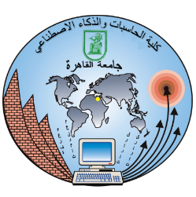

Faculty of Computers and Artificial Intelligence – Cairo University

Web Project – Phase 2
Project: Job Search Website
Team Number: 9

Team members:
1- Elzahraa Radwan Abdo
ID: 20242052
Section: S2
Email: 20242052@stud.fci-cu.edu.eg

2- Soaad Gamal Ahmed
ID: 20242156
Section: All
Email: 20242156@stud.fci-cu.edu.eg

3- Nada Ehab Kamel
ID: 20242370
Section: S2
Email: 20242370@stud.fci-cu.edu.eg

4- Sara Ali Refaey
ID: 20242148
Section: S1/2
Email: 20242148@stud.fci-cu.edu.eg

5- Mennatullah Usama Aowad
ID: 20240615
Section: S1
Email: 20240615@stud.fci-cu.edu.eg

6- Mariem Ahmed Elsayed
ID: 20250900
Section: S1
Email: 20250900@stud.fci-cu.edu.eg

Submitted to: Dr. Neamat El Tazi
TA: Alaa Adel
Submission Date: 12/4/2026

